

PROJECT REPORT

Robotic Project - School year 2022 – 2023

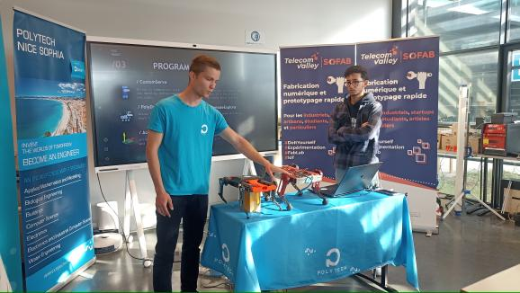POLYDOG_V2

**Year Manager: Students:**

Pascal MASSON Hugo DURAND

Younes BAZI

1. **Introduction**

Legged locomotion requires complex leg mechanism, high power density actuators and advanced control methods, which have prevented the widespread use of legged robots for a long time. But with technological advances, we tend to develop more and more complex and autonomous robots in more rugged environments.

The robotics program at the Polytechnic University of Nice Sophia trains engineers capable of mastering the design stages of an autonomous robotic system. An autonomous system is one that can achieve a given set of goals in a changing environment gathering information about the environment and working for an extended period without human control or intervention (*BlackBerry QNX definition*). Autonomous robots can be used to improve the speed and accuracy of routine operations, particularly in warehousing and manufacturing spaces; work side-by-side with humans for added efficiency; and reduce the risk of employee injury in dangerous environments.

1. **Requirements specification**

|  |  |  |  |
| --- | --- | --- | --- |
| Reference | Functions | Norm | Level |
| FP1 | Moving in a flat environment | Size | 40cmx20cmx10cm (fold up) max |
| Weight | 2,5kg for not buying motors that are too expensive, too much energy input making the robot's autonomy limited |
| Degree of freedom | 6 degrees of freedom: he will be able to curl up, jump, move forwards, backwards, on his right and left side. |
| FP2 | Autonomy | Depth camera | 1 (Infront) seeing 10 meters ahead,  Collision avoidance, 3D scanning, volumetric measurement |
| Battery | Use of a battery to allow it to move outside and in a space not limited to one cable length. |
| Orientation sensor | IMU will provide for us information about our robot’s inclinations, which will help us to stabilize more the robot. |
| FC1 | Adhere to a smooth floor | Grip Foot | Ninja flex or other material to form the feet to have a good support on the ground and move forward efficiently. |
| FC2 | Aesthetics | Design | Aesthetics are very important for the general public's view and simply to please (color, form, hide the wires). |
| FC3 | Facilitate easy assembly and disassembly | Design | The different parts must be easy to dismantle to be able to test, change a defective motor or have access to the control board for a code upload if necessary. |
| FC4 | An ergonomic and user-friendly result | Ergonomic | The robot must be easy to operate by any user, without having to know anything about electronics and/or computers science |

1. **Circuit diagram**

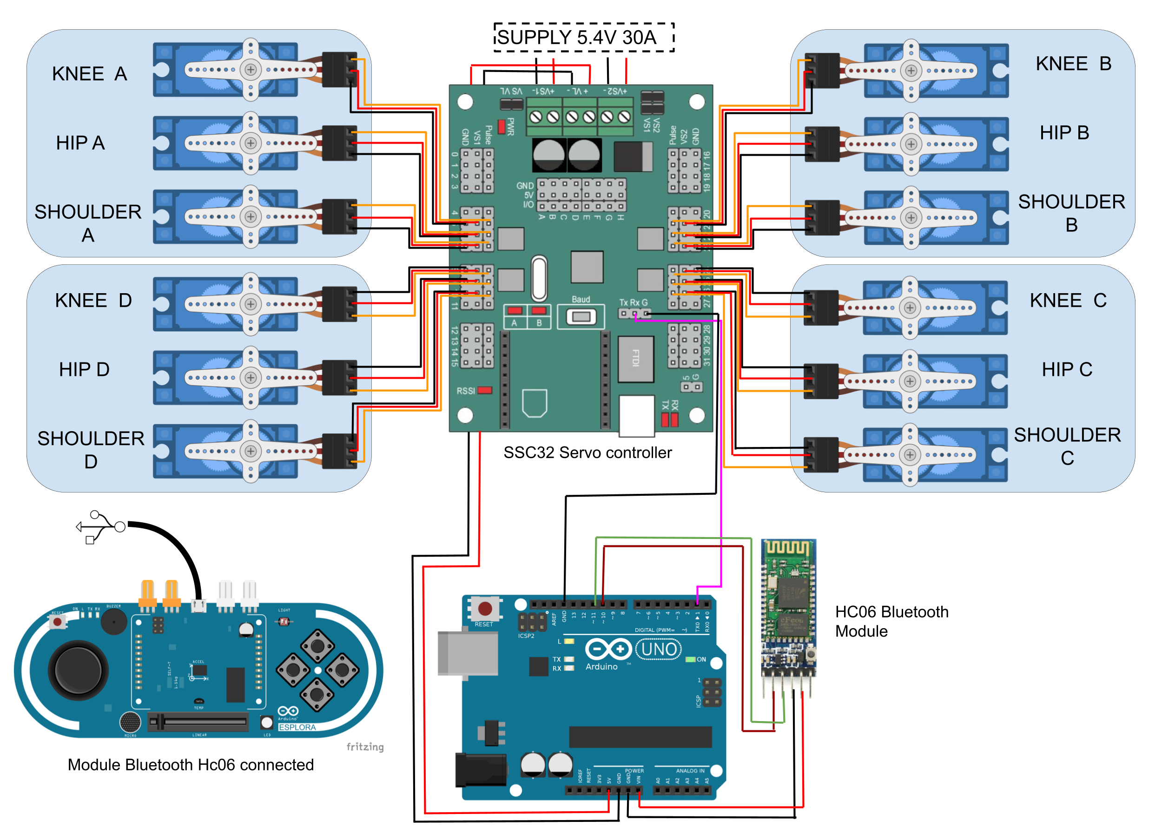The robot dog is equipped with 12 TD8135MG servo motors 35kg/cm of torque, which are controlled by a motor driver SSC 32. The reading of the user's guide was essential for us to understand the functioning of the card, especially the power options (VS1, VS2, VL). We supply the logic circuit VL with the Arduino board and we connect the two power channels VS1 and VS2 under 5.4 V for the servo motors with a power supply providing up to 50A.

Fig 1 : Electronic diagram of the robot. Black wires indicate GND, red wires indicate VCC, yellow wires indicate PWM.

1. 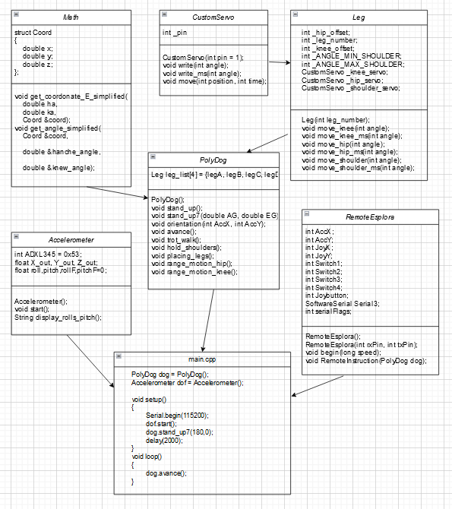**Algorithms**

The algorithm starts with the commands sent to the ssc32 servo controller, via the serial communication by sending string data of this type: "#<motor_pin>P<angle between 500-2500 microseconds> T<time in milliseconds>" from the Arduino Uno and converts them into control signals for the servomotors.

We have implemented a basic function that manages the sending in a class named CustomServo. We, then build a Leg class to instantiate each leg and correct imprecisions and offset between the legs and make sure that the 4 legs form a rectangle on a table. PolyDog class record empirically constructed movement patterns such as trot_walk(), stand_up(), composed by a list of position command in this form: “legA.move_hip(95);”

Fig 2: Diagram of the program’s classes architecture and the logical links between them

1. **Project cost (material + engineer cost)**

We can estimate the material cost of the project, although component prices may vary depending on available inventory at the time of purchase.The addition of the Nvidia card would add an additional cost of 200euros. We realize that the cost of the robot is very low, if we make comparisons with what exists on the market. If the robot works properly, it could bring a better accessibility to the public or for routine tasks.We sincerely believe that we spent much more time on it than just the same amount of time spent in class, but I think that's already a good estimate of the time spent on it.

Fig 3 : Estimation table of the cost of the material + engineer cost starting from a gross annual salary of 38 keuros for 1600h of work.

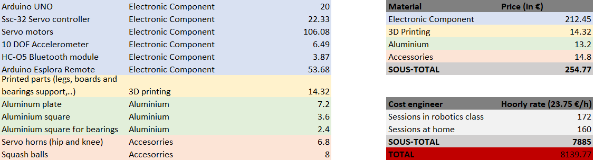

1. **Return to the bibliography**

In the bibliography, I was very interested in rebuilding the robot with lighter materials (carbon fiber, thinner aluminum) and more fluid joints. This was not done, except that we put grease to reduce friction.

As for the configuration of the leg, since the robot was already built, we had no problem there.

We did not start finally on the possibility of testing brushless motors, can be an excellent idea, seen the difficulties met by the SnoopyTech team.

We also didn't focus on the addition of depth camera and battery because we were entirely focused on the robot walking, to make it work properly.

In the bibliography, the only element we did not explicitly mention and did it during the rest of the year was the simulation aspect.

1. **Problems encountered**

We faced problems with power supply and power supply by faulty electrical cables. We have therefore modified the voltage delivered by the power supply to the servo motors by 0.5V to avoid harmful drop voltages and changed the cables of higher section.

We are also having a lot of trouble finding a stable position for the robot to stand in and not fall when it lifts a leg. We have not figured out how to lift a front leg and a back leg in the same position without falling. So, we then skipped this step to try to make the robot walk at a certain speed so that it is not the time to fall on one side.

Then, we tried to model the robot on several simulation software in order to test it with inverse kinematics. We encountered many problems to import the robot and adding the corrects joints. But with CoppeliaSim, we reached to do it and makes the robot walking and move in his environnement pretty well. However we didn't yet manage to send the differents joints angles proprely because it sends to many angles at the same times and the clock time inside the simulator is not the same as the real time.

Additionally, we faced a setback in our attempts to transmit the joint values to the Jetson Nano through Ros. This hurdle arose due to a malfunctioning WiFi adapter on the Jetson Nano itself. Since the transmission of information was intended to occur wirelessly via WiFi in Ros, the malfunctioning adapter posed a significant challenge. Our objective was to wirelessly relay the joint values from CoppeliaSim to the Jetson Nano, and subsequently transmit them to the servo motors.

1. **Conclusion & Perspectives**

From an objective point of view, we are able to send a set of motion patterns to the robot and it executes the sequence. The robot is able to move in a simulation environment, it is able to walk forward , backwards, sideways, turn around itself, execute some in-place maneuvers, AND with the help of the PID control system , the Polydog is able to make rapid adjustments to maintain its balance and stability, even when faced with unexpected conditionse. We are able to choose the height at which it raises its paw and the distance at which it rests it on the ground.

The robot math, to calculate by hand, the set of angles that the motor servos should receive from the height of the robot and the distance at which id should move, is not yet fully working, but it's just a matter of time because it's just calculations. This will be done during the summer vacations.

What I would like to do for this summer is to solve definitively the problems of lack of strength of the servo motors. As suggested to me by two mechanics teachers, I need to relieve the servos from forcing directly on the ground to keep the leg where it should be and use only gears. I have solved this problem for the shoulders in the new version, I need to make the knees and hold the other end of the hip for more stability.

I would also like to get a power supply that delivers 6V to make sure it delivers enough power to the servo motors. Finally, I would like to try to put metal joints for the legs to smooth the movement and reduce the force required.

Next, we would like to take the time to test the power and capacity of the leg alone on a vertical metal bar to see how high it can jump, as most engineers do when testing their legs. Then rebuild it and test paws that I calculated with our inverse kinematics math.

1. **Links**

N. Schaller, “Birds on the run: what makes ostriches so fast?” in the scienceinschool.org website, November 22, 2011

R. Anjou, H. Durand, Polydog_version1 in Instructables, a website specialized in DIY projects, <https://www.instructables.com/Polydog-Arduino-Project/>

R Keith Mobley, 39 - Gears and Gearboxes, in Plant Engineer's Handbook, 2001

Gaudenz Alder, Draw. Io, diagrams.net, a free and open-source cross-platform graphic drawing software developed in HTML5 and JavaScript.

Lynxmotion_ssc-32u_usb_user_guide

Pascal Masson, “Eléments de robotique avec Arduino, Communications RF”, <http://users.polytech.unice.fr/~pmasson/Enseignement.htm>

Introduction to CoppeliaSim Course , robotics courses at the Universitat Politècnica de València : [https://www.youtube.com/watch?v=PwGY8PxQOXY&list=PLjzuoBhdtaXOoqkJUqhYQletLLnJP8vjZ*](https://www.youtube.com/watch?v=PwGY8PxQOXY&list=PLjzuoBhdtaXOoqkJUqhYQletLLnJP8vjZ*)

ROS Tutorials :

<https://wiki.ros.org/ROS/Tutorials>